**Your Task**

**Write the missing JavaScript code** to make the **Forum** work as expected:

All fields **(title, category,** and **content)** are **filled with the correct input**

* + **Title, category,** and **content** are **non**-**empty** **strings**. If any of them are empty, the program should not do anything.

1. **Getting the information from the form**

When you click the **["Publish"]** button, the information from the input fields must be added to the **ul** with the **id** **"review-list"** and **then clear input fields**.

The HTML structure looks like this:

Картина, която съдържа текст

Описанието е генерирано автоматично

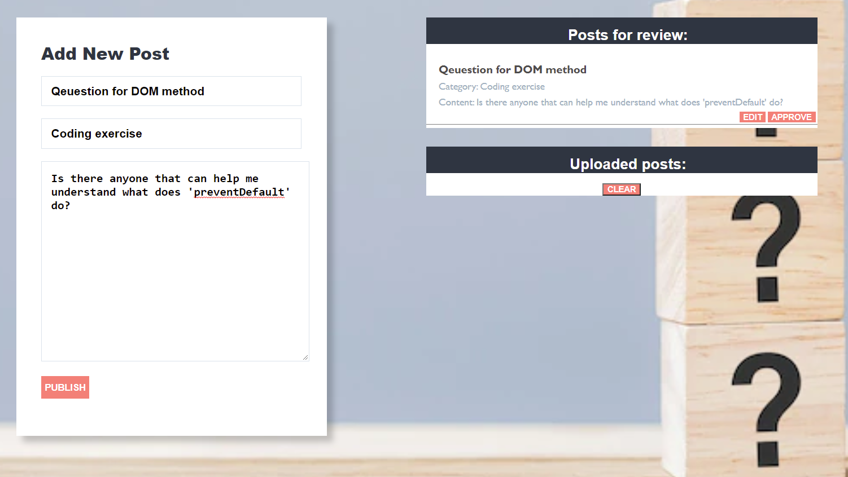

# Edit information for posts

When the **["Edit"]** button is clicked, the information from the post must be sent to the input’s fields and the record should be deleted from the **ul** **"review-list"**.

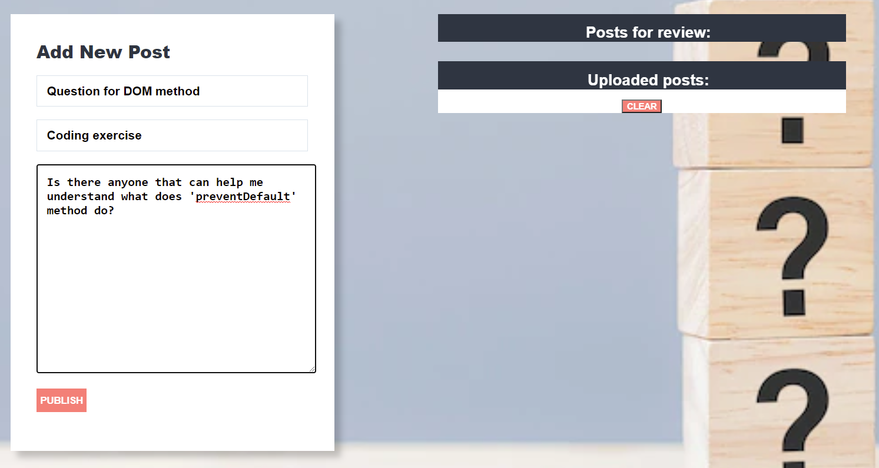

After editing the information make a new record to the **ul** with updated information.

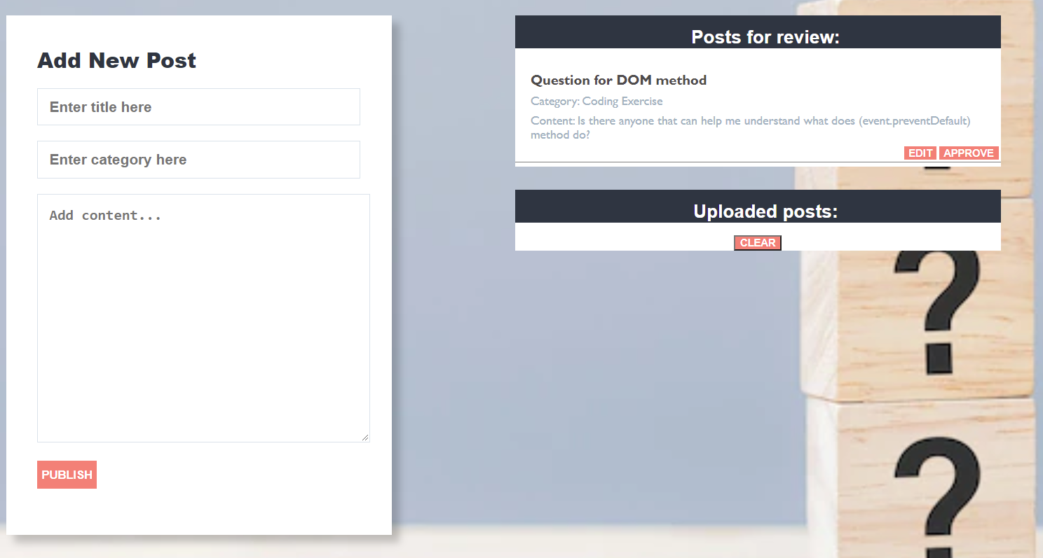

# Approve posts

When you click the **["Approve"]** button, the record must be **deleted** from the **ul** with **id "review-list"**and appended to the **ul** with the **id** **"published-list"**

The **buttons [“Edit”]** and **[“Approve”]** should be removed from the **li** element.

Картина, която съдържа текст

Описанието е генерирано автоматично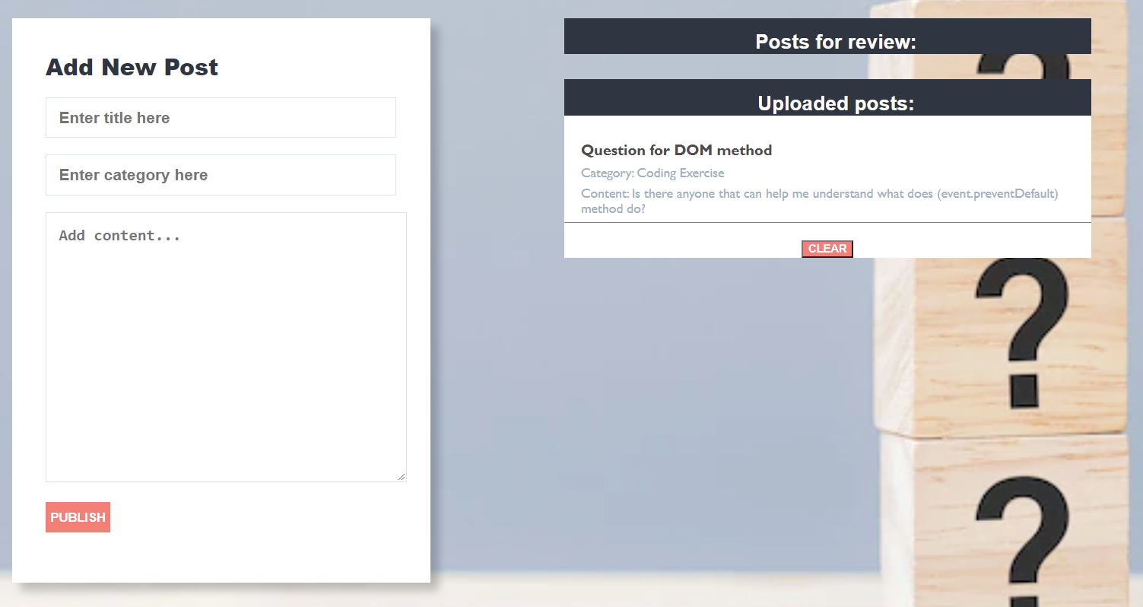

# Clear posts

When you click the **["Clear"]** button, the record for all posts must be **deleted** from the **ul** with the **id** **"published-list".**

